rc-Mirrors-2012

**...** discussion of the lion motif in Chinese mirrors: " the 'Dance of the Lions of the Five Directions,' accompanied by the 'Music of Universal Peace,' was a popular musical performance at the Chinese court during the Sui and the T'ang.

# Kaikodo journal

, Issue 11

Kaikodo, 1999

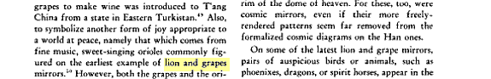

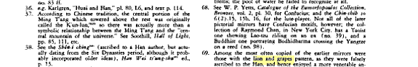

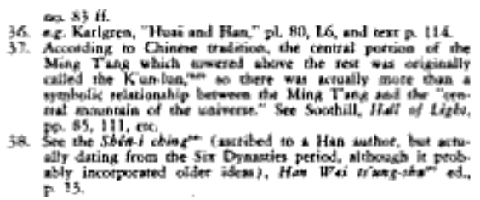

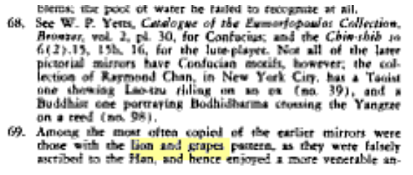

# Archives of the Chinese Art Society of America

, Volumes 9-12

Chinese Art Society of America, 1955